** ICAR-CENTRAL INLAND FISHERIES RESEARCH INSTITUTE**

**(INDIAN COUNCIL OF AGRICULTURAL RESEARCH)**

BARRACKPORE: KOLKATA - 700 120

Phone No. (033) 2592 1190/1191

E-mail: [cifri@vsnl.com](mailto:cifri@vsnl.com), Website: cifri.res.in

|  |  |
| --- | --- |
| F. No. Swachh Bharat/Adm.II/ | Dated 26th October, 2017 |

**Pre-dipawali Swachhta activities in ICAR-CIFRI:-**

**At Barrackpore:-**

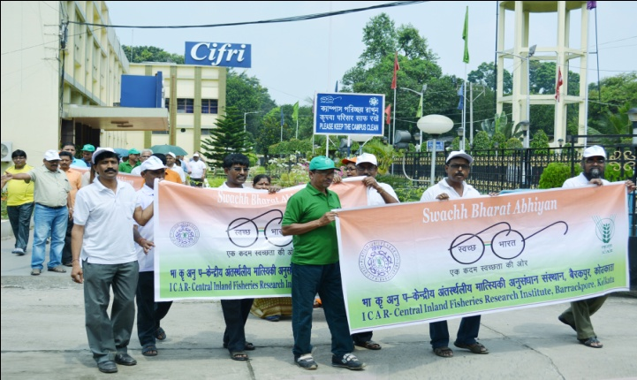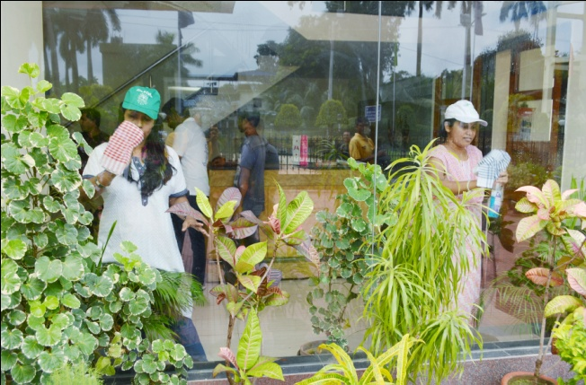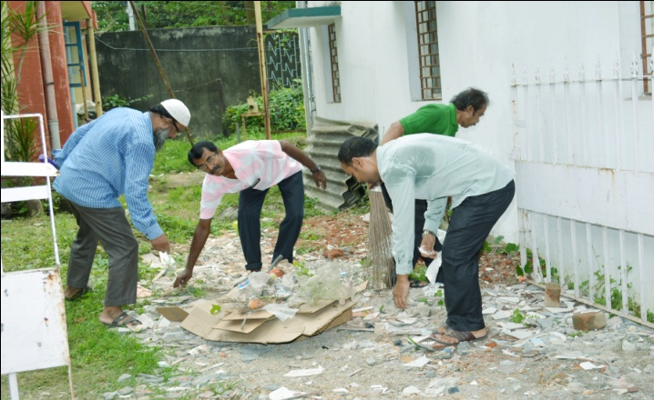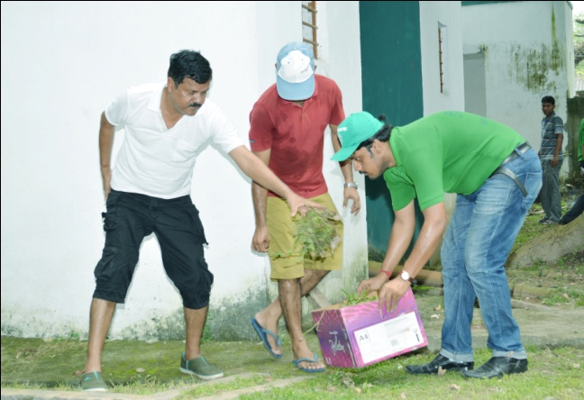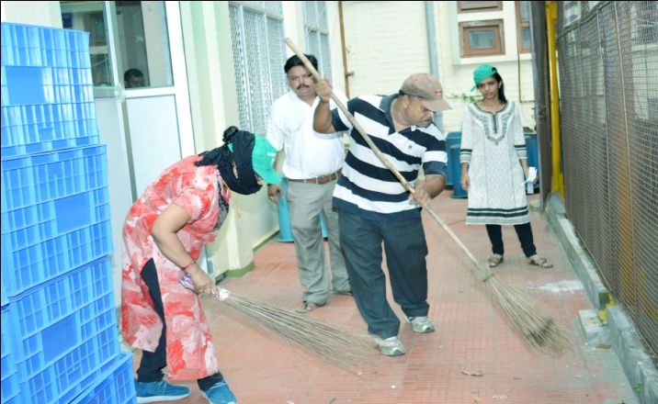 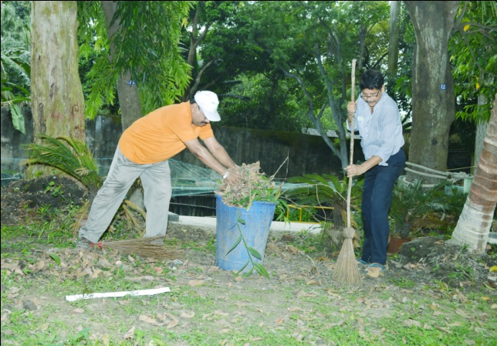

**At Allahabad:-**

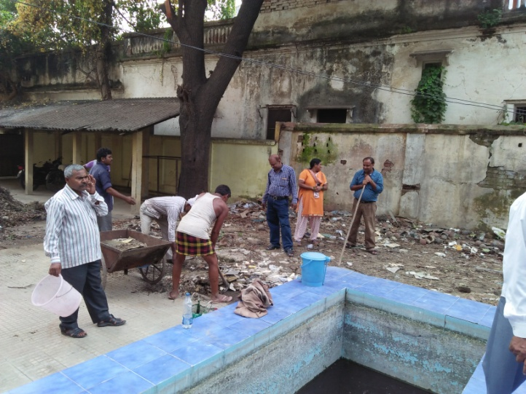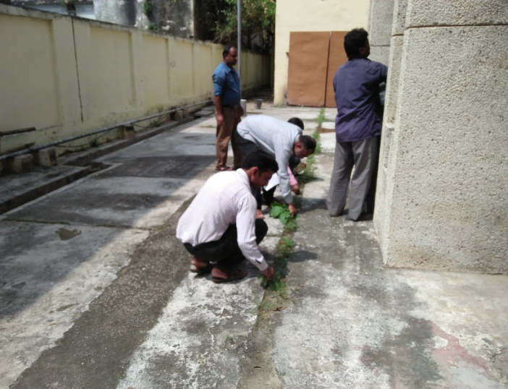 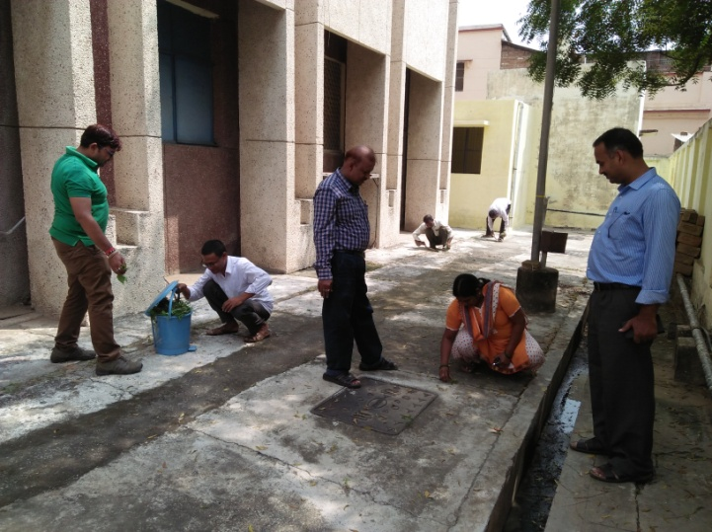 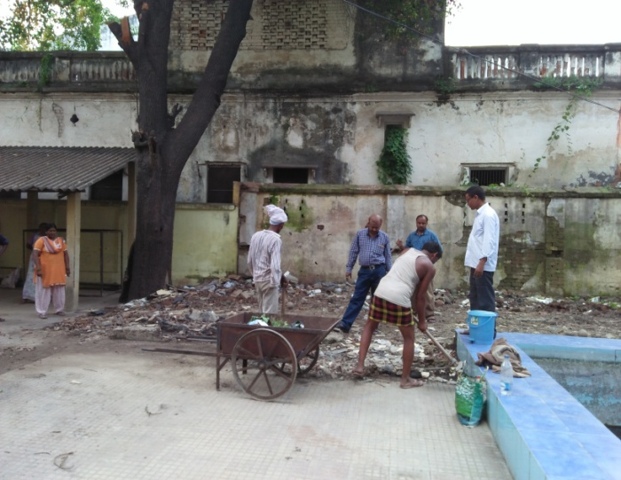

**At Vadodara:-**

